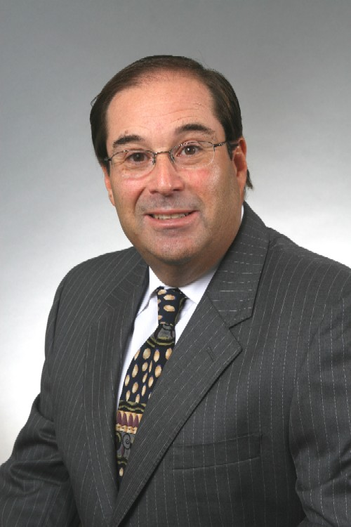

STEVEN R. ROSENBAUM, C.P.A.

PROFILE:

Over 25 years of diversified public accounting experience:
- Certified Public Accountant -- Florida 1991, (New York 1982 currently inactive)
- Member of the American and Florida Institutes of Certified Public Accountants
- Certified Fraud Examiner, 1995
- Certified Specialist in Estate Planning, 1999
- Certified in Financial Forensics, a designation issued by American Institute of Certified Public Accountants, 2008
- Bachelor of Science in Accounting from Fairleigh Dickinson University, 1978, Magna Cum Laude

Steven R. Rosenbaum CPA

PAST EXPERIENCE:
1992 - 2011 DAWSON, ROSENBAUM & SOBEL, P.A.
Certified Public Accountants
Coconut Grove, Florida
Partner in charge of Tax, Insolvency, and Litigation Services
    - Responsible for all aspects of the firm's tax practice including review of corporate, individual, and fiduciary income tax returns, representation of clients during tax examinations, tax research, tax planning, and IRS collection matters.
    - Supervision of bankruptcy engagements, assisting troubled debtors through the Chapter 11 process including attendance at court hearings, assisting counsel in preparation of reorganization plans, preparation and review of various filings required by the U.S. Trustee's office.
    - Litigation support services, recreated accounting history in a major South Florida ponzi scheme involving more than 15,000 victims, divorce matters, audited royalty receipts received by a performer from a record company, reviewed financial transactions and alleged loans by an "Accountant/Business Manager" to a professional athlete who he allegedly defrauded.
    - Served as court appointed receiver for an operating manufacturing business embroiled in a bitter divorce battle. Oversaw the Companies profitable operations for six months.
    - Implemented the firms' computer network, including hardware and software selection. This state-of-the-art system has enabled the firm to prepare all tax returns in-house, which reduces turn-around time to our clients while achieving overall cost savings.
    - Active in the firm's marketing program, coordinated development of the firm's brochure and Internet web site.
    - Responsible for business planning for many of the firm's small business clients and their principals.

Steven R. Rosenbaum CPA

1986 - 1991 RICHARD A. EISNER & COMPANY
New York, New York Manager, Small Business Services Department
Now known as, Eisner Amper Accountants and Advisors the 15th largest Public Accounting in the United States
1978 - 1986 VARIOUS MEDIUM-SIZED C.P.A. FIRMS
New York, New York
Senior Accountant

PUBLIC SERVICE:

2000 - 2004 Miramar Pembroke Pines Regional Chamber of
Commerce
Vice Chair of Finance, Board Member

2000 - 2003 Florida Bar Grievance Committee, Eleventh
Judicial Court

To e-mail Steven R. Rosenbaum, C.P.A.: Srrcpa@hotmail.com

